**PROJECT 2**

**COFFEESHOP MANAGEMENT**

**INSTALLATION GUIDE**

**Software requirement:**

* XAMPP with MySql version 5.2.0 or higher.
* NetBeans IDE or Intelij IDEA with version jdk8. Screen with resolution >1280x900(FullHD).

**Step 1. Install the database:**

First, if there is already a database with the name ‘coffeeshop’ in phpMyAdmin, please drop it before proceeding.

Second,create the database using ‘Import’ in phpMyAdmin to import file ‘coffeeshop.sql’ .



**Step 2. Install the application source code:**

Download or copy source code folder into the folder where NetBeans or Intelij is installed.

Example:

* C:\Documents\NetBeansProjects\Project2
* C:\IdeaProjects\ Project2

**Step 3. Check the connection:**

The connection to the database was defined in the file: Project2/ConnectVariable.txt . If your server has different configuration (host name, username, password…), you should check this file and change the information accordingly.

- localhost is your server’s name.

- coffeeshop is database’s name.

- root is your password.

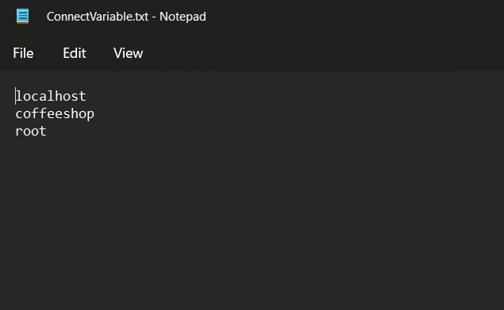

**Step 4. Access application:**

To access the application, please open your IDE and run the project.

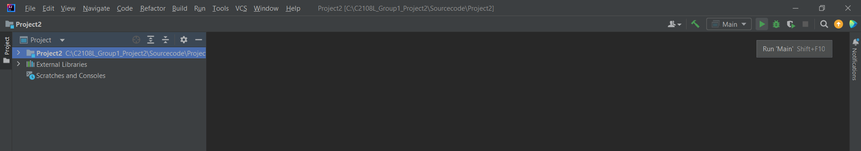

To login the admin section, please use the following information:

Username: admin

Password: admin

This is the root account which has the highest authority. You may use it to create other account or change the password if you want but remember to keep this account safe!

For technical support please contact us: vinh.nq.1932@aptechlearning.edu.vn

============================END INSTALLATION GUIDE=============================